1. Install Ubuntu from Microsoft Store
2. 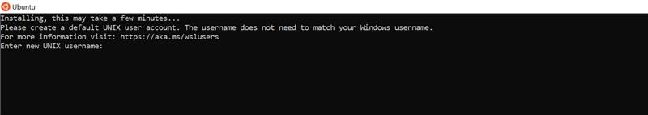
3. Username – “enter your username” Password – “choose password”
4. <https://pureinfotech.com/install-windows-subsystem-linux-2-windows-10/>
5. <https://dev.to/bartr/install-docker-on-windows-subsystem-for-linux-v2-ubuntu-5dl7>
6. For docker compose run “sudo curl -L "<https://github.com/docker/compose/releases/download/1.24.0/docker-compose-$(uname> -s)-$(uname -m)" -o /usr/local/bin/docker-compose”
7. Now you can run docker compose command to run dependencies like below

